**PROJECT REPORT**

**Introduction:**

This project is to develop an idea which helps to control the water supply to tank regularly based on the water quantity in the tank.

This was developed using atmega328 microprocessor, ultrasonic sensor and servo motor actuator.

A pseudo code of C language is developed and programmed to achieve the objectives.

**Objectives**:

1. To sense the water level in the tank regularly.
2. Programming the atmega microprocessor in a way which can drives the servo based on the inputs received.
3. To actuate the servo motor which works as an actuator at the final part.

**Components used:**

1. Atmega microprocessor.
2. Ultrasonic sensor.
3. Servo motor with an actuator.
4. LED indicators.
5. Battery input.

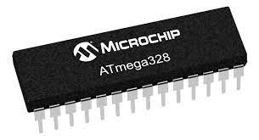

**Pin diagram of atmega328:**

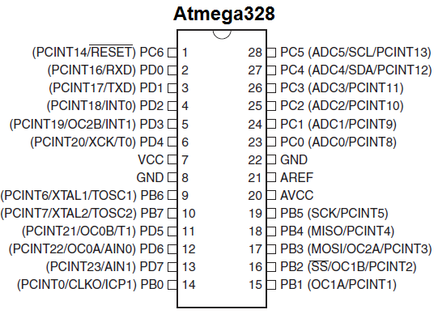

**Flow chart:**

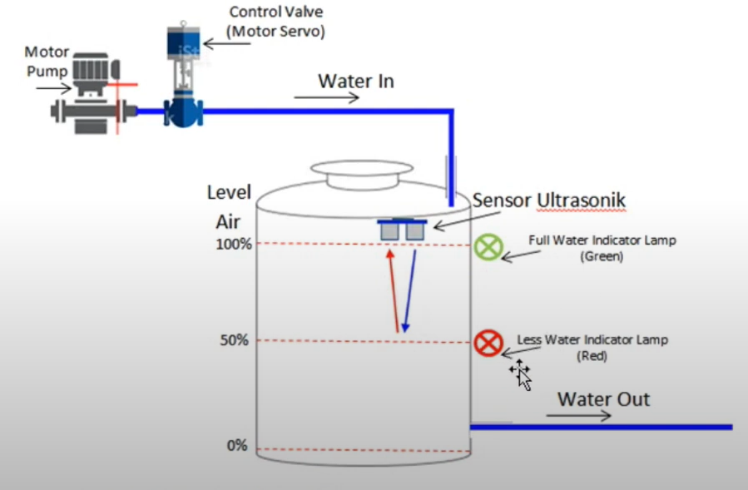

Tank inlet

Servo actuator

Controlled output

Battery input

Ultrasonic sensor

Atmega 328

**Architecture:**

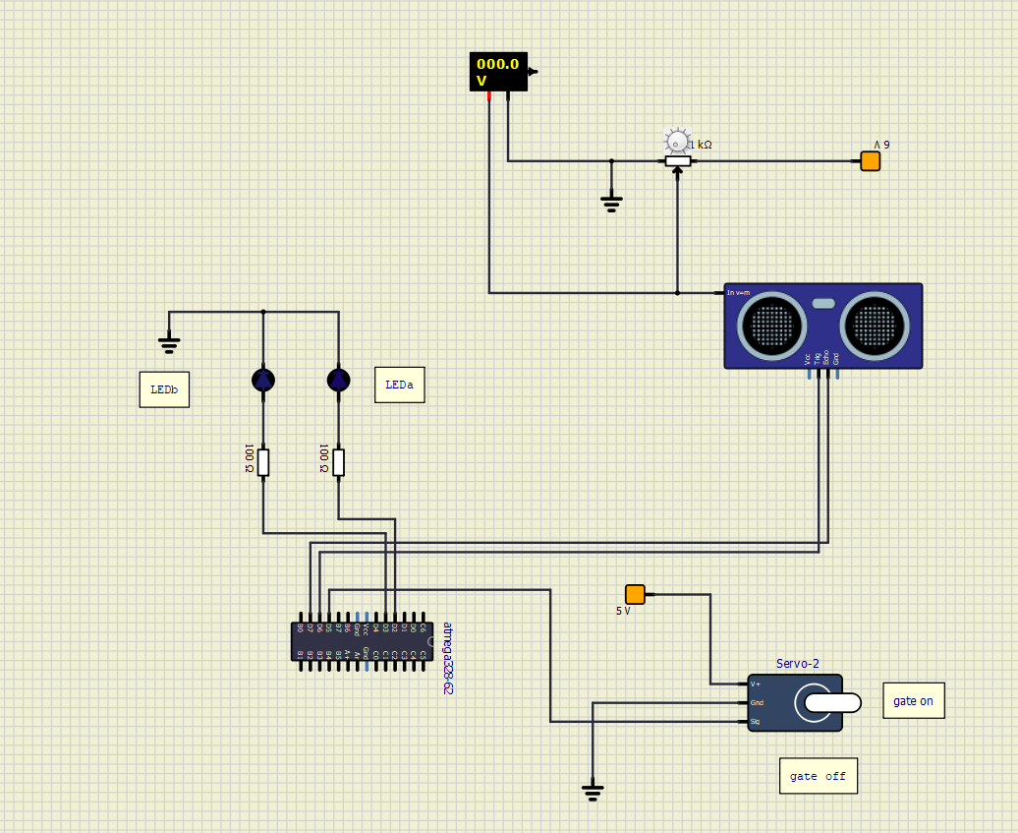

**Pseudo code:**

A code is written in C language and executed in Arduino IDE software.

After the testing it is uploaded to the atmega 328 processor.

#include <NewPing.h>

#include <Servo.h>

#define trigPin 12

#define echoPin 13

#define MAX_DISTANCE 50

NewPing sonar(trigPin, echoPin, MAX_DISTANCE);

int LEDa = 2, LEDb = 3;

Servo myservo;

void setup()

{

Serial.begin (115200);

pinMode (trigPin, OUTPUT);

pinMode (echoPin, INPUT);

pinMode (LEDa, OUTPUT);

pinMode (LEDb, OUTPUT);

myservo.attach(9);

}

void loop()

{

int duration, distance, positio=0, i;

digitalWrite(trigPin, LOW);

delayMicroseconds(2);

digitalWrite(trigPin, HIGH);

delayMicroseconds(10);

digitalWrite(trigPin, LOW);

duration = pulseIn(echoPin, HIGH);

distance = (duration/2) / 29.1;

Serial.print(distance);

Serial.println("cm");

if(distance<=5)

{

digitalWrite(LEDa, HIGH);

digitalWrite(LEDb, LOW);

myservo.write(180);

}

else

{

digitalWrite(LEDb, HIGH);

digitalWrite(LEDa, LOW);

myservo.write(90);

}

delay(450);

}

**Working**:

The project is executed and simulated in SimulIde software.

Gate on: when the input value i.e., distance of water level from the top is more than the restricted distance the gate valve is turned on.

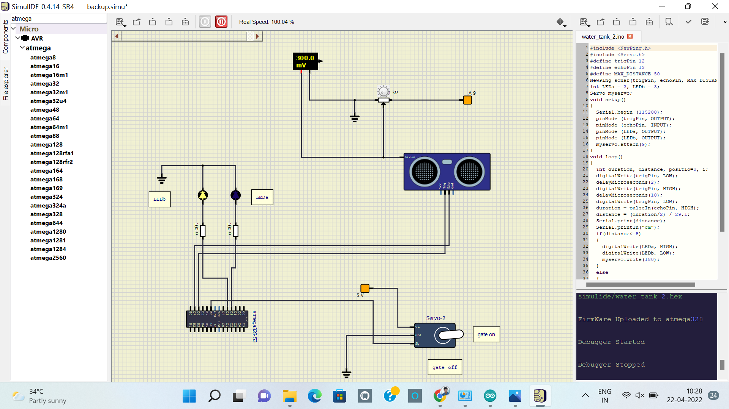

Gate off: when the input value i.e., distance of water level from the top is less than the restricted value the gate valve is turned off.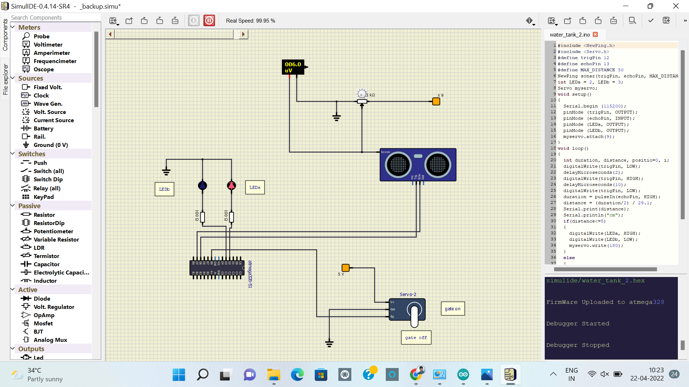

**Result:**

The project is constructed as per the requirements in the SimulIDE software and executed successfully. And achieved the objectives in the working of the atmega in the software.